BUSINESS INSIGHT REPORT
DATASET: GLOBAL SALES & FINANCIAL PERFORMANCE
INTERACTIVE SALES DASHBOARD ANALYSIS
PREPARED BY
VAISHNAVI K

1. INTRODUCTION

This report presents a structured analysis of the "Global Sales & Financial Performance" dataset, visualised through an interactive Power BI sales dashboard. The purpose of this report is to translate the dashboard's visual insights into a clear, written business analysis covering overall performance, product category trends, seasonal sales patterns, regional distribution, and employee contribution.

The dashboard consolidates transactional sales data across multiple years, regions, product categories, and employees, allowing decision-makers to monitor Key Performance Indicators (KPIs) and identify actionable opportunities. This report interprets those visuals to support data-driven business recommendations for inventory planning, marketing, regional expansion, employee performance, product portfolio strategy, and customer targeting.

2. DASHBOARD OVERVIEW
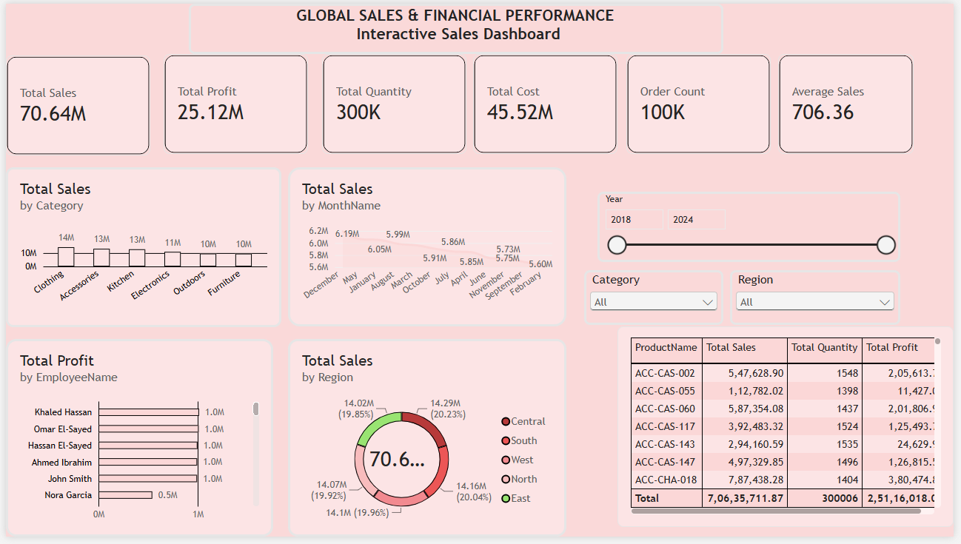

The dashboard titled "Global Sales & Financial Performance – Interactive Sales Dashboard" provides a single-page, filterable view of company-wide sales performance. It includes six summary KPI cards (Total Sales, Total Profit, Total Quantity, Total Cost, Order Count, and Average Sales), a bar chart of sales by product category, a line chart of sales by month, a donut chart of sales by region, a horizontal bar chart of profit by employee, and a detailed product-level data table. Interactive slicers for Year, Category, and Region allow users to filter every visual dynamically, making the dashboard a flexible tool for both high-level monitoring and detailed drill-down analysis.
3. KPI ANALYSIS
The KPI cards at the top of the dashboard summarise overall business performance across the full 2018–2024 period:
Total Sales | 70.64 Million
Total Profit | 25.12 Million
Total Quantity Sold | 300,000 units
Total Cost | 45.52 Million
Order Count | 100,000 orders
Average Sales Value | 706.36 per order

The overall profit margin is approximately 35.6% (Total Profit ÷ Total Sales), indicating healthy profitability relative to cost of goods. With 100,000 orders generating 300,000 units sold, the average order contains roughly 3 units, and the average revenue per order stands at 706.36. This combination of a high order count and moderate average order value suggests a business driven by frequent, mid-sized transactions rather than a small number of large-ticket sales, which is typical of a broad retail or e-commerce sales model.
4. PRODUCT CATEGORY PERFORMANCE ANALYSIS
The "Total Sales by Category" bar chart shows six product categories, with sales ranging narrowly between 10M and 14M. Clothing leads with approximately 14M in sales, followed closely by Accessories and Kitchen at around 13M each. Electronics contributes about 11M, while Outdoors and Furniture each generate approximately 10M.
The relatively even spread across categories (a difference of only about 4M between the highest and lowest performing category) indicates a well-diversified product portfolio with no single category dominating overall revenue. This balance reduces business risk from over-reliance on one product line, but it also means that most categories have room for targeted growth initiatives, particularly Furniture and Outdoors, which currently trail the others.
5. MONTHLY SALES TREND ANALYSIS
The "Total Sales by MonthName" line chart tracks sales across all twelve months, with values ranging from approximately 5.60M to 6.19M. The chart shows a gently declining trend: the strongest months sit above 6.0M, while later points in the sequence taper down toward 5.6M–5.75M.
Overall, the month-to-month variation is modest (roughly a 10% spread between the highest and lowest months), which suggests relatively stable, non-seasonal demand rather than sharp peaks tied to specific holidays or events. This stability is favourable for inventory and staffing forecasts, though the gradual downward drift toward the lower-performing months is worth monitoring and may benefit from targeted promotional campaigns to smooth out demand.
6. REGIONAL SALES ANALYSIS
The "Total Sales by Region" donut chart divides total sales of 70.64M across five regions: Central (14.29M, 20.23%), East (14.16M, 20.04%), West (14.1M, 19.96%), North (14.07M, 19.92%), and South (14.02M, 19.85%).
Regional performance is exceptionally balanced, with each region contributing close to an equal one-fifth share of total sales (all within a 0.4 percentage-point range of one another). This even distribution indicates a mature, geographically diversified sales footprint. Central is the marginal leader, while South is the marginal laggard — the gap between them is small enough that regional strategy should focus on maintaining consistency rather than correcting a major imbalance.
7. EMPLOYEE PERFORMANCE ANALYSIS
The "Total Profit by EmployeeName" chart ranks six employees by profit contribution. Khaled Hassan, Omar El-Sayed, Hassan El-Sayed, Ahmed Ibrahim, and John Smith each contribute approximately 1.0M in profit, forming a tightly clustered top group. Nora Garcia contributes roughly 0.5M, noticeably lower than the rest of the team.

The strong, consistent performance among five of the six employees suggests effective and standardised sales practices across most of the team. Nora Garcia's profit contribution, at roughly half of her peers, stands out as an area warranting attention — whether through additional training, mentoring from top performers, or review of account/territory assignments to identify the underlying cause of the gap.
8. BUSINESS RECOMMENDATIONS
Based on the KPI, category, trend, regional, and employee analysis above, the following recommendations are proposed:
• Inventory Planning: Maintain higher safety stock for Clothing, Accessories, and Kitchen given their consistently strong demand, while right-sizing inventory for Furniture and Outdoors to avoid overstocking slower-moving categories.
• Marketing Strategy: Launch targeted promotions in the lower-performing months (later in the trend, around 5.6M–5.75M) to smooth seasonal dips, and run cross-category bundle campaigns pairing top categories (Clothing, Accessories) with slower ones (Furniture, Outdoors).
• Regional Expansion: Since regional sales are already well balanced, focus new investment on sustaining consistency across all five regions rather than large reallocation; pilot small growth initiatives in South, the current marginal laggard, to close the small remaining gap with Central.
• Employee Performance: Pair Nora Garcia with a top-performing colleague (e.g., Khaled Hassan or Omar El-Sayed) for mentoring, and review whether territory, account size, or product mix assignment is contributing to the profit gap, then set incremental improvement targets.
• Product Portfolio: Invest further in Furniture and Outdoors through improved merchandising, pricing review, or new product additions to help these categories close the gap with the top-performing Clothing, Accessories, and Kitchen lines.
• Customer Targeting: With an average order value of 706.36, introduce loyalty offers, volume discounts, or upsell prompts at checkout to increase basket size, and use the high order count (100K) to build a customer segmentation strategy for repeat-purchase campaigns.

